ASSIGNMENT 6
Que 1.Write two differnt querise that would produce all orders taken on october 3rd or 4th , 1990
A.
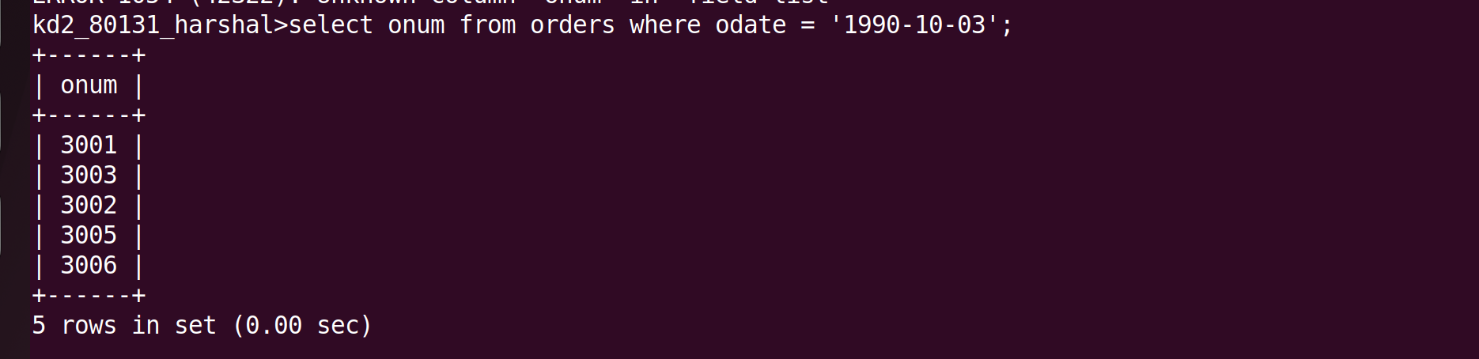
B.
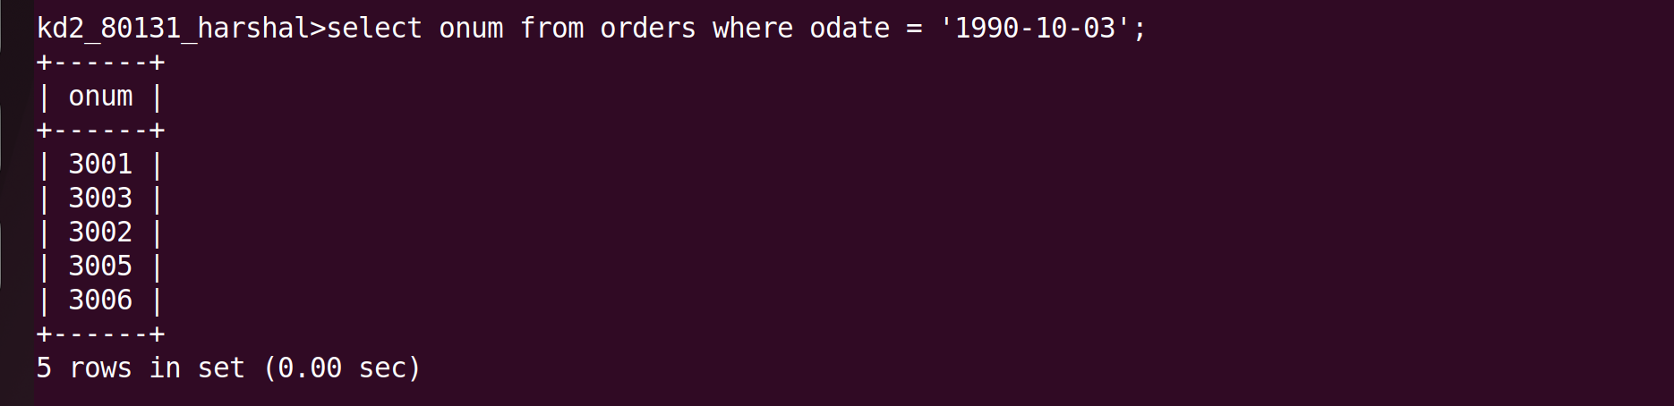
Que 2. Write a query that selects all of the customers serviced by peel and motika .
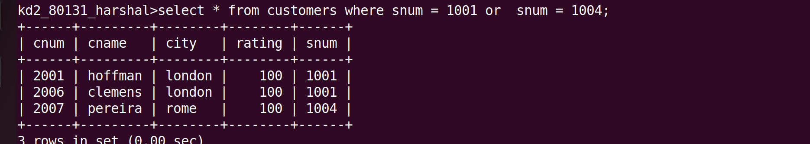

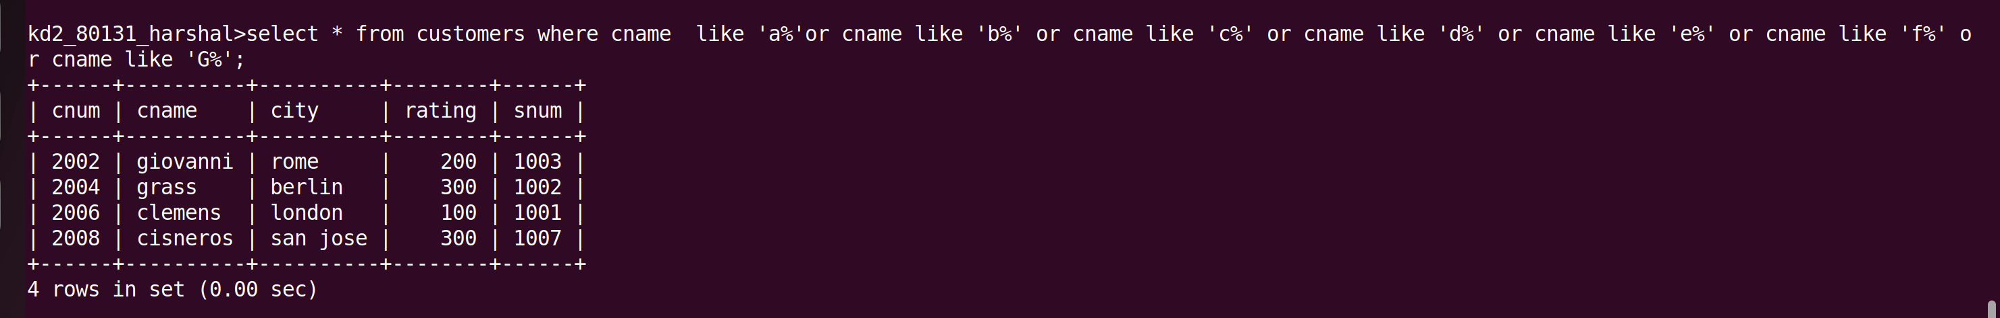
Que 3. Write a query that will produce all the customers whose names begin with the letter from ‘A’ to ‘G’

Que 4. Write a query that selects all customers whose namwe begin with the letter ‘c’
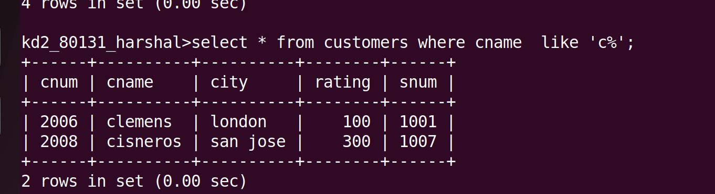
Que 5. write a query that selects all orders except those with zerose or NULLs in the amt filed

